Dibble Public School

Chad Clanton, Superintendent Mechell Prince, Elementary Principal
Darlene Hayhurst, Middle School Principal Damon Garner, High School Principal/Athletic Director
Krista Cochran, Secondary Counselor Becky Lee, Elementary Counselor

P.O. Box 9 ● Dibble, Oklahoma 73031 ● Phone (405) 344-6380 ● Fax (405) 344-6977

Dear Families,
It is important to remember that your student’s strengths, abilities and potential cannot be measured by a single test score. Each student grows at different rates, both physically and academically. State tests help gauge how your student is growing in the knowledge and skills outlined in the Oklahoma Academic Standards. State test results, when combined with other information (i.e., report card grades, teacher feedback, classroom performance and local tests), can help you and your local school support your student’s growth.
Your student’s state test results will be available at the end of May in the OSTP Student/Family Portal.
The portal can be found here:
https://okparentportal.emetric.net/login
If you have not already set up an account, you will need your student’s 10-digit State ID (STN) number and date of birth. If you have last year’s OSTP results, the 10-digit State ID (STN) can be found on the front page of the report. It is labeled State ID and is located beneath your student’s name and local ID number. The State ID can also be found on your child’s final report card.
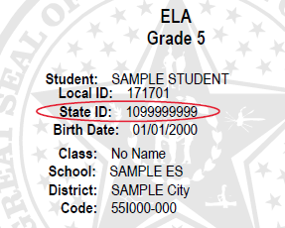
If you do not currently have access to either document showing to your student’s 10-digit State ID (STN), please contact us at lee@dibble.k12.ok.us for Elementary and Middle School or cochran@dibble,k12.ok.us for High School.
Information provided in the portal helps you know:
- How your student performed in each key academic area
- Where your student is doing well and where they may need additional support at home and at school
- How your student performed compared to others

Thank you for your time,
Becky Lee, M.Ed.
Elementary Counselor/Special Ed. Director

